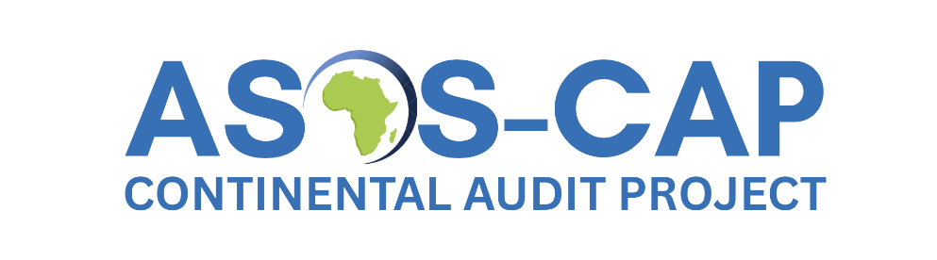
African Surgical Outcomes Study- Continental Audit Project (ASOS-CAP)

BACKGROUND
Safe surgery is important for health. Yet, we know that more patients die after surgery in Africa than in other parts of the world. There are many possible reasons for this. Unfortunately, we do not know all the reasons, and therefore we do not know the best way to make surgery safer.
Making surgery safer is a complex problem which cannot be managed with one simple intervention.¹ It will require a group effort by many people to make surgery safer. These changes may include more resources, better education and training, a change in the way we provide care on the ward, and how we work as a team.
To understand ‘why’ patients die, we need a detailed understanding of the many factors which may make some surgeries unsafe.
STUDY OBJECTIVE
The objective of this study is to understand the factors which contributed to any death after surgery in Africa.

STUDY OUTCOME
We will measure what surgery is done, by whom and when. We will analyse any deaths after surgery to understand why a patient died.
STUDY DESIGN
We will use a standard anonymous approach to understand bad outcomes, that have been used to understand what went wrong when mothers die, and when patients have had a cardiac arrest in the United Kingdom.
PATIENT CONSENT
There will be no consent for this study, as it will not change patient care, and we will collect anonymous routine data.
PREPARATION FOR THIS STUDY
The African Perioperative Research Group (APORG) has done many studies of surgery across Africa. This group will now continue with this work, so that we can try find solutions to make surgery safer.
IMPORTANCE OF THIS STUDY
It is hoped that we can make recommendations to hospitals and to governments based on the findings of the study that will make surgery safer in Africa.

REFERENCES
1. Biccard BM, du Toit L, Lesosky M, et al. Enhanced postoperative surveillance versus standard of care to reduce mortality among adult surgical patients in Africa (ASOS-2): a cluster-randomised controlled trial. The Lancet Global Health 2021;9(10):e1391–e401. doi: 10.1016/s2214-109x(21)00291-6

