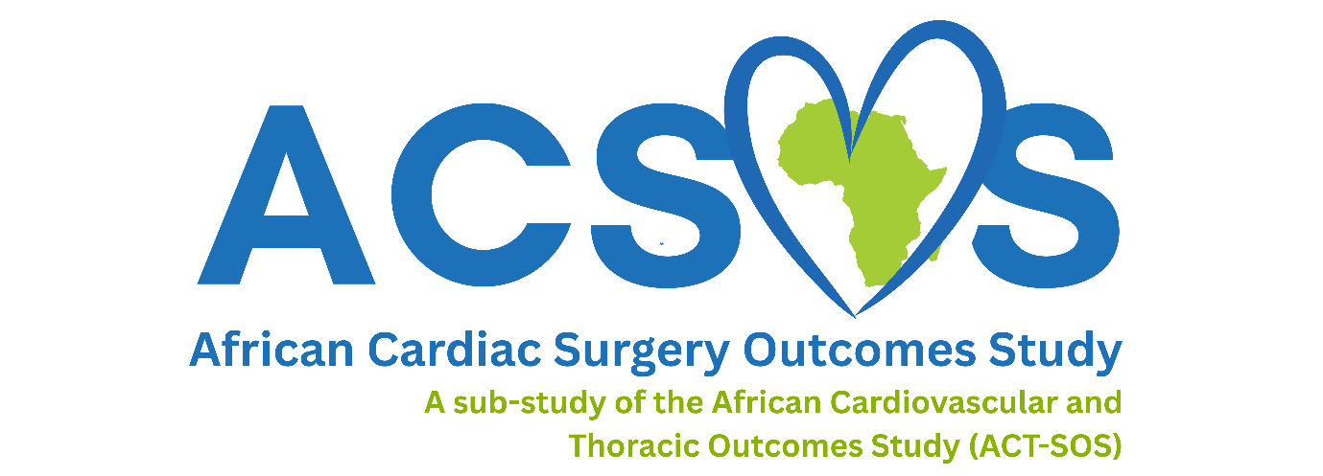
PARTICIPANT CONSENT SHEET

- I have been given a Participant Information Sheet which explains the nature and processes involved in this study, which is attached hereto;
- I was given time to read it, or had it read to me, in the language I best understand;
- I was given time to ask any questions I wanted to and found any answers given to me to be reasonable and satisfactory;
- I believe I fully understand why the study is being conducted and what the intended outcomes will be;
- I understand that there will be no immediate benefit to me, should I agree to participate, nor will I receive any payment; conversely, participation will not cost me anything but my time;
- I understand that, even if I initially consent to take part in the study, I may subsequently withdraw at any time and would not be required to give any reasons; if that happened, any data collected about me for the purposes of the study would immediately be destroyed, unless I give consent for it to be retained
- I have been given a range of contact details, listed below. If I require further information or become concerned about any aspect of this study I am free to speak to any of these contacts.

Contact details:

Professor Palesa Motshabi-Chakane, Principal Investigator, telephone no. +27117172990, or by e-mail at palesa.motshabi@wits.ac.za,

Moses Mogakolodi Kebalepile, Project Coordinator and Investigator, on telephone no. +27727532466, or by e-mail at moses.kebalepile@wits.ac.za

Professor P Ruff, Chairperson of the Human Research Ethics Committee (Medical) at the University of Witwatersrand, who may be contacted via any one member of the secretariat. The telephone numbers for the Committee secretariat are 011 717 2700/1234/2656/1252 and the e-mail addresses are Zanele.Ndlovu@wits.ac.za, Rhulani.Mukansi@wits.ac.za, Mapula.Ramaila@wits.ac.za and Iain.Burns@wits.ac.za

Name of Participant: ________________________________________
Date: ________________________________________
Place: ________________________________________
Signature or mark ________________________________________

Witnessed by:
Name of Witness: ________________________________________
Signature: ________________________________________
Date: ________________________________________

PARTICIPANT ASSENT SHEET FOR MINORS*

African Cardiac Surgical Outcomes Study (ACSOS)
An African, multi-centre 28-day evaluation of patient care and clinical outcomes for patients undergoing cardiac surgery
A sub-study of the African Cardiovascular and Thoracic Outcomes Study (ACT-SOS)

- I have been given a Participant Information Sheet for Minors, which explains what this study is about;
- The study was explained to me and I understand what will happen if I take part;
- I was given time to ask any questions I wanted to and was happy with the answers I was given;
- I understand that I will not benefit from the study, should I agree to take part. I also understand that I will not be paid to take part in the study; taking part will not cost me anything either;
- I have been given a range of contact details, repeated below, should I require further information at a later stage, or have any cause for concern over anything which is done to me during the study; and
- I understand that even if I agree to take part in the study, I can change my mind later and stop being a part of the study
- My parent(s) or guardian(s) know that I have been invited to take part in the study. They agree that I may do so, but the decision to take part is also mine.

Contact details:

Professor Palesa Motshabi-Chakane, Principal Investigator, telephone no. +27117172990, or by e-mail at palesa.motshabi@wits.ac.za,

Moses Mogakolodi Kebalepile, Project Coordinator and Investigator, on telephone no. +27727532466, or by e-mail at moses.kebalepile@wits.ac.za

Professor P Ruff, Chairperson of the Human Research Ethics Committee (Medical) at the University of Witwatersrand, who may be contacted via any one member of the secretariat. The telephone numbers for the Committee secretariat are 011 717 2700/1234/2656/1252 and the e-mail addresses are Zanele.Ndlovu@wits.ac.za, Rhulani.Mukansi@wits.ac.za, Mapula.Ramaila@wits.ac.za and Iain.Burns@wits.ac.za

Name of Participant: ________________________________________
Date: ________________________________________
Place: ________________________________________
Signature or mark ________________________________________

Name of Parent or Guardian: _________________________________
Date: ________________________________________
Place: ________________________________________
Signature or mark ________________________________________

Witnessed by:
Name of Witness: ________________________________________
Signature: ________________________________________
Date: ________________________________________
* Defined as being persons under the age of 18

CONSENT SHEET – PARENT/GUARDIAN OF A MINOR¹

African Cardiac Surgical Outcomes Study (ACSOS)
An African, multi-centre 28-day evaluation of patient care and clinical outcomes for patients undergoing cardiac surgery
A sub-study of the African Cardiovascular and Thoracic Outcomes Study (ACT-SOS)

- I have been given a Participant Information Sheet which explains the nature and processes involved in this study, which is attached hereto;
- I was given time to read it, or had it read to me, in the language I best understand;
- I was given time to ask any questions I wanted to and found any answers given to me to be reasonable and satisfactory;
- I believe I fully understand why the study is being conducted and what the intended outcomes will be;
- I understand that there will be no immediate benefit to me or my child, should I agree to participate, nor will I receive any payment; conversely, participation will not cost me anything but my time;
- I understand that, even if I initially consent to take part in the study, I may subsequently withdraw my child’s participation at any time and would not be required to give any reasons; if that happened, any data collected about my child for the purposes of the study would immediately be destroyed, unless I give consent for it to be retained
- I have been given a range of contact details, listed below. If I require further information or become concerned about any aspect of this study I am free to speak to any of these contacts.

Contact details:

Professor Palesa Motshabi-Chakane, Principal Investigator, telephone no. +27117172990, or by e-mail at palesa.motshabi@wits.ac.za,

Moses Mogakolodi Kebalepile, Project Coordinator and Investigator, on telephone no. +27727532466, or by e-mail at moses.kebalepile@wits.ac.za

Professor P Ruff, Chairperson of the Human Research Ethics Committee (Medical) at the University of Witwatersrand, who may be contacted via any one member of the secretariat. The telephone numbers for the Committee secretariat are 011 717 2700/1234/2656/1252 and the e-mail addresses are Zanele.Ndlovu@wits.ac.za, Rhulani.Mukansi@wits.ac.za, Mapula.Ramaila@wits.ac.za and Iain.Burns@wits.ac.za

¹ A minor in South African law is a person under 18 years of age

Name of child: ________________________________________
Name of parent or guardian: _____________________________
Date: ______________________________________________
Place: _______________________________________________
Signature or mark of parent: _____________________________

Witnessed by:
Name of Witness: ________________________________________
Signature: ________________________________________
Date: _______________________________________

